|  |  |  |
| --- | --- | --- |
|  | **ST. FRANCIS INSTITUTE OF TECHNOLOGY**  **Mount Poinsur, Borivali (West), Mumbai-400103**  **Department of Information Technology**  **Information Technology Students’ Association (ITSA)** |  |

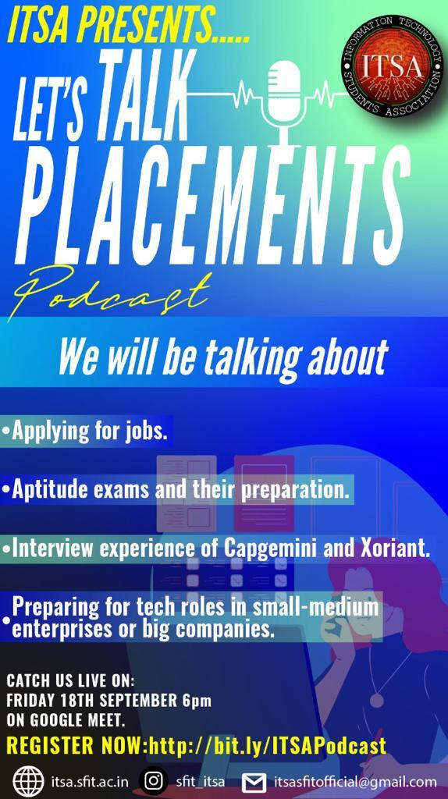

The Podcast started with the Introduction by Joshua Dsouza, President of ITSA for the year 2020-21.All the participants were then welcomed and our four panellists were introduced.

1. Lenin, ex-chairperson of ITSA.

2. Sanket Dalvi, Technical secretary of SFIT for the year 2019-20.

3. Arbaz Khan, pursuing his B.E from St. Francis Institute of Technology.

4. Joel Monis, pursuing his B.E from St. Francis Institute of Technology.

Starting with Lenin telling everyone about himself as to why he joined St. Francis Institute of Technology and the IT Department if he wanted a job in this Department or a similar field. He then asked all the participants why they chose engineering and for their opinions if they joined for the jobs in the Engineering field, if it was their choice or they were pressured into pursuing Engineering. He said the jobs we get in this field mainly depend on the colleges we are in. Lenin also spoke about the webinar which was conducted in the month of May this year about Jobs, how they are affected by COVID-19 and the huge economic crashdown.

Then we had Sanket, he specifically spoke about product and service based companies. He also spoke about the difficulty level of the interviews in these companies. He mentioned that individual growth in these companies is better.

After this we had Joel speaking, he mentioned having a 9 or 10 pointer is not necessary and we must just be confident and positive during our interviews. Then he told everyone about the basic coding skills everyone should have and various other factors like our CV. He said easiest way to get a job is on campus.

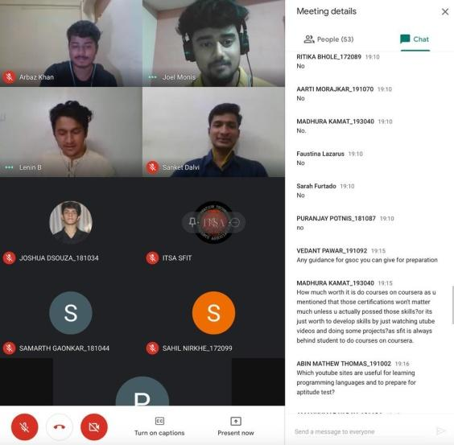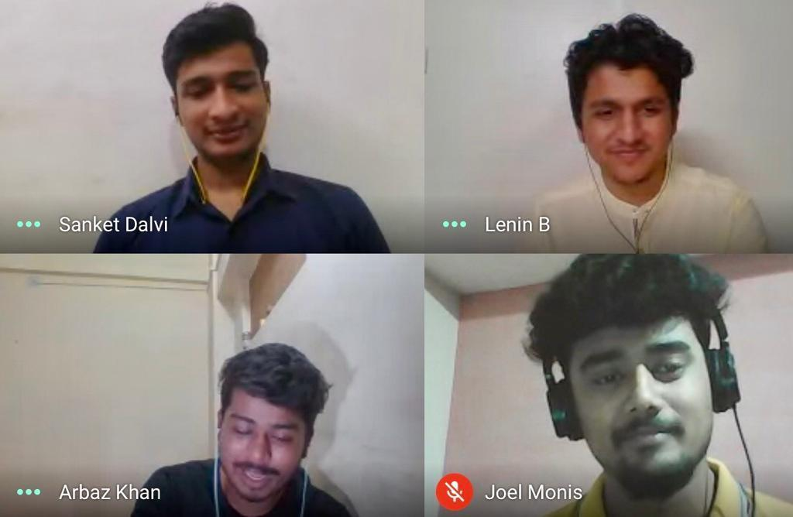

Arbaz spoke about service based companies being less risky compared to product based companies. He advised everyone to work on projects, participate in hackathons due to this working on real life projects will get easier. He also told everyone to do internships because experience is important.

Then we had the QnA session where all of our participants asked various interesting questions based on the jobs and market which were answered by the panellists.

Lenin then gave a vote of thanks to everyone for being present and for listening patiently. And our PR Executive Ms. Faustina Lazarus thanked the panellists for providing us with all the information.

|  |  |  |
| --- | --- | --- |
| **Mrs. GrinalTuscano** | **Mrs. Shree Jaswal** | **Dr.Joanne Gomes** |
| **(ITSA Coordinator)** | **(ITSA Coordinator)** | **(HOD-IT)** |